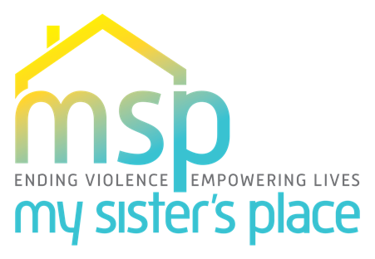

**For Immediate Release:**

February 1st, 2023

**For More Information Contact:**

Mercedes Lemp

Mlemp@mysistersplacedc.org

**Saving Lives with Emergency Cash Transfer Programs**

**Washington, D.C.** - My Sister’s Place (MSP) is proud to launch the first emergency cash transfer program specifically targeted toward domestic violence (DV) survivors. This pilot project will benefit families served through MSP’s Reaching Independence Through Survivor Empowerment (RISE) transitional housing program and is aimed at improving financial stability and economic opportunities for survivors by putting money directly in the hands of the recipients. Cash transfer programs have been offered throughout the country, but none have targeted DV survivors. Yet, we know financial insecurity is the number one reason a survivor might return to an abuser. The program’s intention is to support upward economic mobility and allow survivors to set and meet financial goals that help them gain and maintain safety and self-sufficiency.

“At MSP, we know that the most common reason victims of domestic abuse do not leave their abuser is economic dependency on the abusive partner. We know that lack of financial independence traps people in abusive relationships and is often the reason victims feel the need to return,” said Mercedes Lemp, Executive Director of My Sister’s Place. “A cash assistance program for survivors of domestic violence provides a gateway for survivors to leave abusive relationships and gives them the support they need to rebuild their lives while ensuring financial issues are not a reason to risk their safety.”

To promote long-term financial stability, MSP’s partnership with CAAB provides survivors with a broad range of financial literacy programming including credit score education, assistance with setting up bank accounts, tax preparation support, savings matching programs, and more. These types of resources are not often available to DV survivors. This partnership is a means of building equity for marginalized groups who often don’t get these opportunities.

"We are honored and excited to be partnering with My Sister's Place on this unique and innovative cash transfer program for the benefit of domestic violence survivors,” said Joseph Leitmann-Santa Cruz, CAAB’s CEO & Executive Director. "We applaud the intentionality and strategy to provide access to cash transfers and CAAB's financial empowerment services in order for the participating resilient women to have an opportunity to achieve financial stability and long-term prosperity."

Studies on previous programs demonstrate that most participants spend almost all the payments on rent and/or food and use any remaining funds on debt reduction, investments in small businesses, education, or transportation.

The program will provide 45 families with $500 per month for two years, playing an integral role in setting survivors up to be experts in their own finances. The program is funded through generous financial support from The Greater Washington Community Foundation’s Health Equity Fund and The William S. Abell Foundation.

“The Health Equity Fund at The Greater Washington Community Foundation are honored to support the partnership of My Sister's Place and Capital Area Asset Builders on this very important cash transfer project.” said Dr. Marla M. Dean, Senior Director of the Health Equity Fund. “In a city as wealthy and resourceful as the District, all of its residents should have a basic income - one that allows families to thrive. The Health Equity Fund believes there is an inextricable link between health and wealth and that the goal of health equity begins with economic mobility. The My Sister's Place and Capital Area Asset Builders' partnership is an important step in this process.”

MSP is also proud to work with GiveCard (www.givecard.io) to provide debit cards to the clients who chose this option to receive their funds. “We at Givecard strive to make an immediate impact with the power of our card programs,” said Sofia Pedro, Head of Product. “We are thrilled to work with My Sister’s Place DC...with their decades-long history as an institution making a difference in the world, we are excited to facilitate their financial assistance efforts so that they may make an even greater impact going forward.”

**###**

**About My Sister’s Place:**

For over 40 years, MSP has been an innovator in changing lives by providing DC’s first hotline and one of the first domestic violence shelters. MSP also offered the first Abuser Intervention Group. As one of DC’s oldest domestic violence shelters, we have served as a cornerstone of the District’s response to this pressing public health issue since 1979, and our impact on DC’s community continues to grow. MSP is unique in offering a full continuum of care from emergency shelter through transitional-to-permanent housing. Families in RISE transitional housing receive wraparound services in addition to rent paid by MSP for one year. Our experienced team of case managers and residential counselors provide clinical counseling, case management, and comprehensive wrap-around services to empower survivors to recover and thrive. MSP also provides training, education, and advocacy to engage communities in preventing violence and abuse. Our goal is to end the cycle of domestic violence and empower everyone to build healthy lives and relationships. [www.mysistersplacedc.org](http://www.mysistersplacedc.org).

**About Capitol Area Asset Builders:**

Capital Area Asset Builders (CAAB) is a non-profit organization based in Washington, DC with a mission to create opportunities for low- and moderate-income individuals in the greater DC region to build financial security, savings, and wealth for the future.

[www.caab.org](http://www.caab.org)